Cypress Lakes High School Vehicle Regulations
2022-2023

1. Permit must be placed inside the front window above the vehicle registration sticker.

- Driving privileges and parking permit can be revoked, without a refund, for violating parking regulations, or as a result of Code of Conduct violations such as, but not limited to, leaving school without permission.

- All student parking will be in the BACK athletic parking lot (behind the school). The small parking areas by the ABC Portables and Auditorium will be staff parking only. Only staff and students with an early release sticker will be allowed to park in the front of the building. Vehicles parked in an unauthorized area will be subject to tow.

- Students will be given one warning and parent notification will be made. Vehicles will be subject to tow for a repeat offense.

- If the vehicle is parked illegally and it becomes necessary for the vehicle to be towed, all the expenses incurred will be the student's responsibility. Vehicles that do not have a parking permit or are improperly parked shall be towed away by a bonded commercial wrecker. It will be the responsibility of the student and/or owner of the car to recover the vehicle and pay for tow-away charges. Contact – BEAR CREEK AUTO STORAGE 281.463.8081.

- No sticker will be replaced unless the old sticker, or a large portion of it, is brought into the Assistant
Principal's office.

- Vehicles parked on school properly are under the jurisdiction of the school. The school reserves the right to search any vehicle if reasonable cause exists to do so.

- Students are not allowed to go to their vehicle during the school day without permission from the Assistant Principal’s office.

- Students will be held responsible for any prohibited objects or substances, such as alcohol, drugs, and/or weapons that are found in their cars and will be subject to disciplinary action.

- If you are temporarily driving a different vehicle, come to the Admin Red office and sign the "Do Not Tow" list. Anyone driving a replacement vehicle for longer than 3 days will need to speak to the AP secretary in Admin Red to get a temporary tag.

- Parking stickers may not be resold. If you find you no longer need a parking permit, please return the unused sticker to the AP office for a full refund.
- Any person involved in an accident while on school property must share pertinent information such as, but not limited to; name, address, driver’s license, and insurance carrier with all parties involved. Failure to exchange information may result in loss of parking privileges and/or other disciplinary consequences.
- Students will not be permitted to speed (over 15mph), back-in park., park in a fire lane or sit in a parked vehicle during school hours.

Parking Map
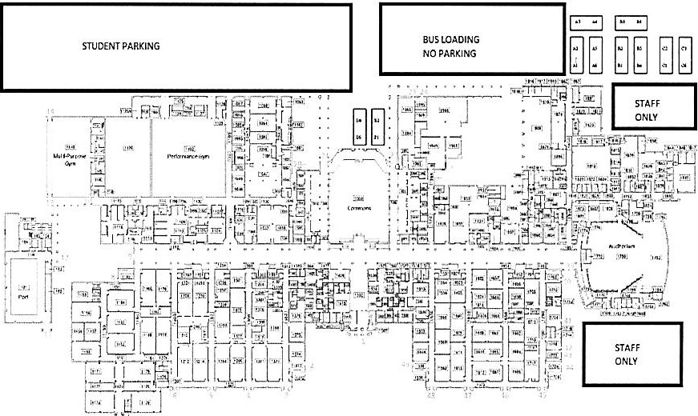

STAFF AND EARLY RELEASE PARKING ONLY

